**Session 1**

Introduction to the Constitution of India [05.10.2020]

The Constitution is the supreme law of the country and all other law-making authorities must abide by it. They are constrained by the constitution in various forms and to different degrees. Most importantly, the constitution provides a guideline, a framework, for governing principles and procedures, ruling practices, right of citizens, their powers and of course their duties.

Constitution is not created by the parliament. It was formed by the constituent assembly after strenuous researches, discussions, surveys, and other such monumental efforts.

The Constitution of India was adopted on 26th November, 1949. However, it came into effect on 26th of January,1950. 26th of January is celebrated as the Republic Day of India.

**Question 1: What is Constituent Assembly? Who were its members and what were their responsibilities? (5 Marks)**

**Solution:**

A *constituent assembly* or constitutional assembly is a body or assembly of popularly elected representatives which is assembled for the purpose of drafting or adopting the constitution similar document. The constituent assembly is entirely elected by popular vote that is, all constituent assemblies are constitutional conventions, but a constitutional convention is not necessarily a constituent assembly.

The Constituent Assembly appointed a total of 22 committees to deal with different tasks of constitution-making. Out of these, eight were major committees and the others were minor committees.

**Major Committees**

1. Drafting Committee – B.R. Ambedkar
2. Union Power Committee – Jawaharlal Nehru
3. Union Constitution Committee – Jawaharlal Nehru
4. Provincial Constitution Committee – Vallabhbhai Patel

5. Advisory Committee on Fundamental Rights, Minorities and Tribal and Excluded Areas – Vallabhbhai Patel

6.House committee – B Pattabhi Sitaramayya

7.Language committee – Moturi Satyanarayana

8.Order of business committee – K M Munshi

Their responsibilities were to completely analyse the internal affairs of the country and to frame the Constitution of India, to give the rights equally to all citizens of the country.

**Task 1: Find out and write how many amendments, article, parts and schedules currently our Constitution consists of. (5 Marks)**

**Solution:** The following lists contains the number of amendments, articles, parts and schedules that our Constitution consists of,

* 1. No. of Amendments : 104 as of January, 2020
  2. No. of Articles : 395 articles
  3. No. of Parts : 22
  4. No. of schedules : 12 and 5 appendices

**Task 2: Draw/Paste Preamble. Explain the key terms mentioned in it. (10 Marks)**

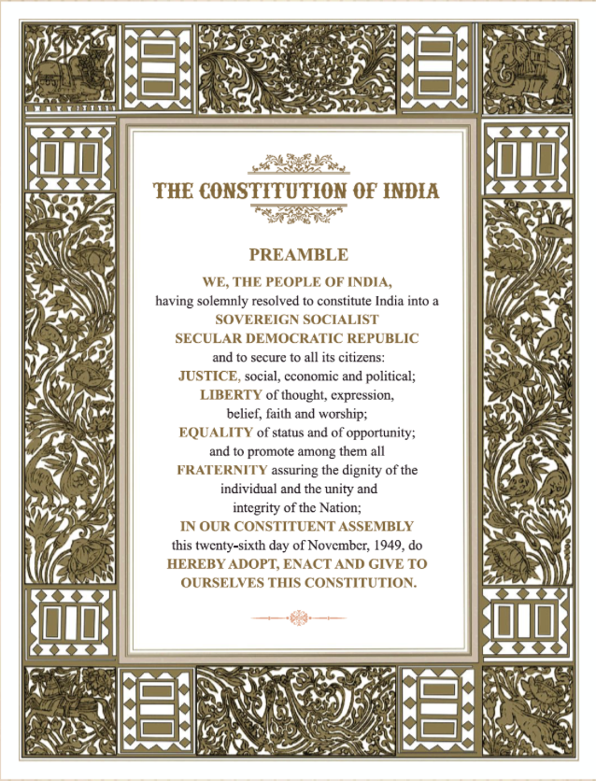

The Preamble to the Constitution of India is a brief introductory statement that sets out guidelines, which guide the people of the nation, and to present the principles of the Constitution, and to indicate the source from which the document derives its authority, and meaning.

1. **Sovereign:**  It means the independent authority of a State. It means that it has the power to legislate on any subject; and that it is not subject to the control of any other State / external power.

2. **Socialist:**  The term socialist used here refers to democratic socialism, i.e. achievement of socialist goals through democratic, evolutionary and non-violent means. Essentially, it means that (since wealth is generated socially) wealth should be shared equally by society through distributive justice, not concentrated in the hands of few, and that the government should regulate the ownership of land and industry to reduce socio-economic inequalities.

3. **Secular:** Secular means that the relationship between the government and religious groups are determined according to constitution and law. It separates the power of the state and religion. There is no difference of religion *i.e.* Hinduism, Buddhism, Jainism, Sikhism, Christianity and Islam are equally respected and moreover, there is no state religion.

4**. Democratic:** The people of India elect their governments by a system of universal adult franchise, popularly known as "one person one vote". Every citizen of India 18 years of age or older and not otherwise debarred by law is entitled to vote. The word *democratic* refers not only to political democracy but also to social and economic democracy.

5. **Republic:** In a republican form of government, the head of state is elected and not a hereditary monarch. Thus, this word denotes a government where no one holds public power as proprietary right. As opposed to a monarchy, in which the head of state is appointed on a hereditary basis for life or at least until abdication, a democratic republic is an entity in which the head of state is elected, directly or indirectly, for a fixed tenure.

### 6. Justice: Justice stands for rule of law, absence of arbitrariness and a system of equal rights, freedom and opportunities for all in a society.

India seeks social, economic and political justice to ensure equality to its citizens.

*(i) Social Justice:*

Social Justice means the absence of socially privileged classes in the society and no discrimination against any citizen on grounds of caste, creed, colour, religion, gender or place of birth.

*(ii) Economic Justice:*

Economic Justice means no discrimination between man and woman on the basis of income, wealth and economic status. It stands for equitable distribution of wealth, economic equalities for everyone.

*(iii)* *Political Justice:*

Political justice means equal, free and fair opportunities to the people for participation in the political process. It stands for the grant of equal political rights to all the people without discrimination.

7. **Liberty:** The idea of Liberty refers to the freedom on the activities of Indian nationals. This establishes that there are no unreasonable restrictions on Indian citizens in term of what they think, their manner of expressions and the way they wish to follow up their thoughts in action.

8. **Fraternity:** This refers to a feeling of brotherhood and a sense of belonging with the country among its people. It embraces psychological as well as territorial dimensions of National Integration. It leaves no room for regionalism, communalism, casteism etc., which hinders the unity of the State.

Indian citizens have six fundamental rights: Right to Freedom, Right to Equality, Cultural, and Educational Rights, Right to Constitutional Remedies, Right against Exploitation. Lately, the Right to Privacy has also been added to the fundamental rights.

**Question 2: What is the difference between constitutional and fundamental rights? (5 Marks)**

**Solution:**

***Fundamental Rights:***

* The fundamental Rights are the basic and inalienable rights granted to every citizen of India and in some cases to non-citizens too. Some of the fundamental rights are:

(a) Right to Equality

(b) Right to Freedom

(c) Right against Exploitation

(d) Right to Freedom of Religion

(e) Cultural and Educational Rights

(f) Right to Constitutional Remedies

These laws are so powerful that no power on Earth, even the Parliament of India can take these from us.

***Constitutional Rights***

* A Constitutional Rights is the supreme right guaranteed by the Constitution of India. It means that if any law contradicts with Constitutional Rights, it will be declared null and void. These rights are not the basic rights and do not apply to everyone, unlike fundamental rights.

------------------------------------x---------------------------------

|  |  |
| --- | --- |
| NAME | DEBARGHYA BARIK |
| REG. NO | RA2011026010022 |